GIZ-MARKET ORIENTED AGRICULTURE PROGRAMME
(MOAP)

Draft

FARMING AS A BUSINESS

TRAINING MANUAL FOR

FACILITATORS

CONTENT

MODULE 1.
The Farm as a Business
Understanding the definition of Business
The Business as a Flow Chart
The Farm in the Business Flow Chart
Comparing the Farm Business with Other Businesses
The Foundations of a Successful Farm Business

MODULE 2
Farm Planning
Principles of Planning
Planning a New Farm or an Existing Farm
Gross Margin Calculation
MODULE 3.
Farm Record Keeping
Farm Record Keeping

Module 1 Session 1
1.0. THE FARM AS A BUSINESS
Training Steps
Session Objectives
Overall Objectives:
To enable farmers who are into the production of crops supported by MOAP to run their farms like any other business.
After going through this session, participants should be able to:
- Define what a business is and give examples of the different type of businesses
- Describe the business process as a flow chart
- Compare the farm business with any other business
- State and explain the pillars on which any successful farm business should stand
Training Materials: Flip Chart or Chalk board, drawings/ pictures
Session Delivery Steps
- Ask the participants for their understanding of what a business is and to give examples from their locality
- Develop the explanations given to fit the diagram of the business process flow chart
- Distribute the business flow chart diagram to the participants and explain the business process to them
- Discuss with participants the details of the business process using the business already mentioned as examples
- Aske participants to compare the farming business with any other business they know or are doing.
- Ask participants whether the farm business they are doing fits into the process above and try to find out from them why this has not been the case all this while, if any?
- Discuss with the participants at which stage(s) of the business process that they have failed in dealing with appropriately?
- Participants should be encouraged to share their views as to how they will deal with the process now that they are aware.
NOTES TO THE FACILITATOR
1.1 Introduction
Most farmers in Ghana do not consider farming as a form of business and do it as a way of life. Those who even consider farming as a business venture do not run it on sound business lines. Farming like any other business provides sustenance (basic and other needs) of the farmer and the other people who depends on him/ her and it is therefore crucial that the activity is run sucessfully. This means that farmers must be educated that farming is a form of business and should be run as such.
1.2 What is a Business?
In very simple term a business “is an activity that someone undertakes to make a product/ service which he sells for a profit”. To further explain this, a business includes the following:
- the owner, who organizes resources to set up the business,
- he/ she makes a product/ service.
- the product/ service is sold in the market or to a buyer
- a profit is made on the product/ service sold
Farming therefore fits into the explanation given above. The farmer is the owner; who organizes resources (land, tools, seedlings, people, chemicals etc.) to set up the farm to produce crops. The produceis sold on the market and profit is made.
1.2 The Business as a Flow Chart
Every business (micro, small, medium or large) can be considered as a series of elements which are linked together. The elements include the person, an activity, a product/service, a market and profit/loss. Putting the elements together a business can be described as a person or company who undertakes an activity that comes out with a product or service which is offered for sale on the market and profit/loss is made. All the elements must be present and functioning for the business to be complete. The diagram below explains the business flow chart.
Fig. 1. The Business Flow Chart

Profit/Loss
Market
Product/
Service

An
Activity
The
Owner

1.2. The Farm in the Business Flow Chart
In the description of a farm business, the person is the farmer, the activity is the crop farm which s/he cultivates, the product is the harvested produce which is sold on a market and profit/loss is made at the end of the season. The flow chart below describes how the farm fits into the business flow chart.
Fig. 2. The Farm Business Flow Chart

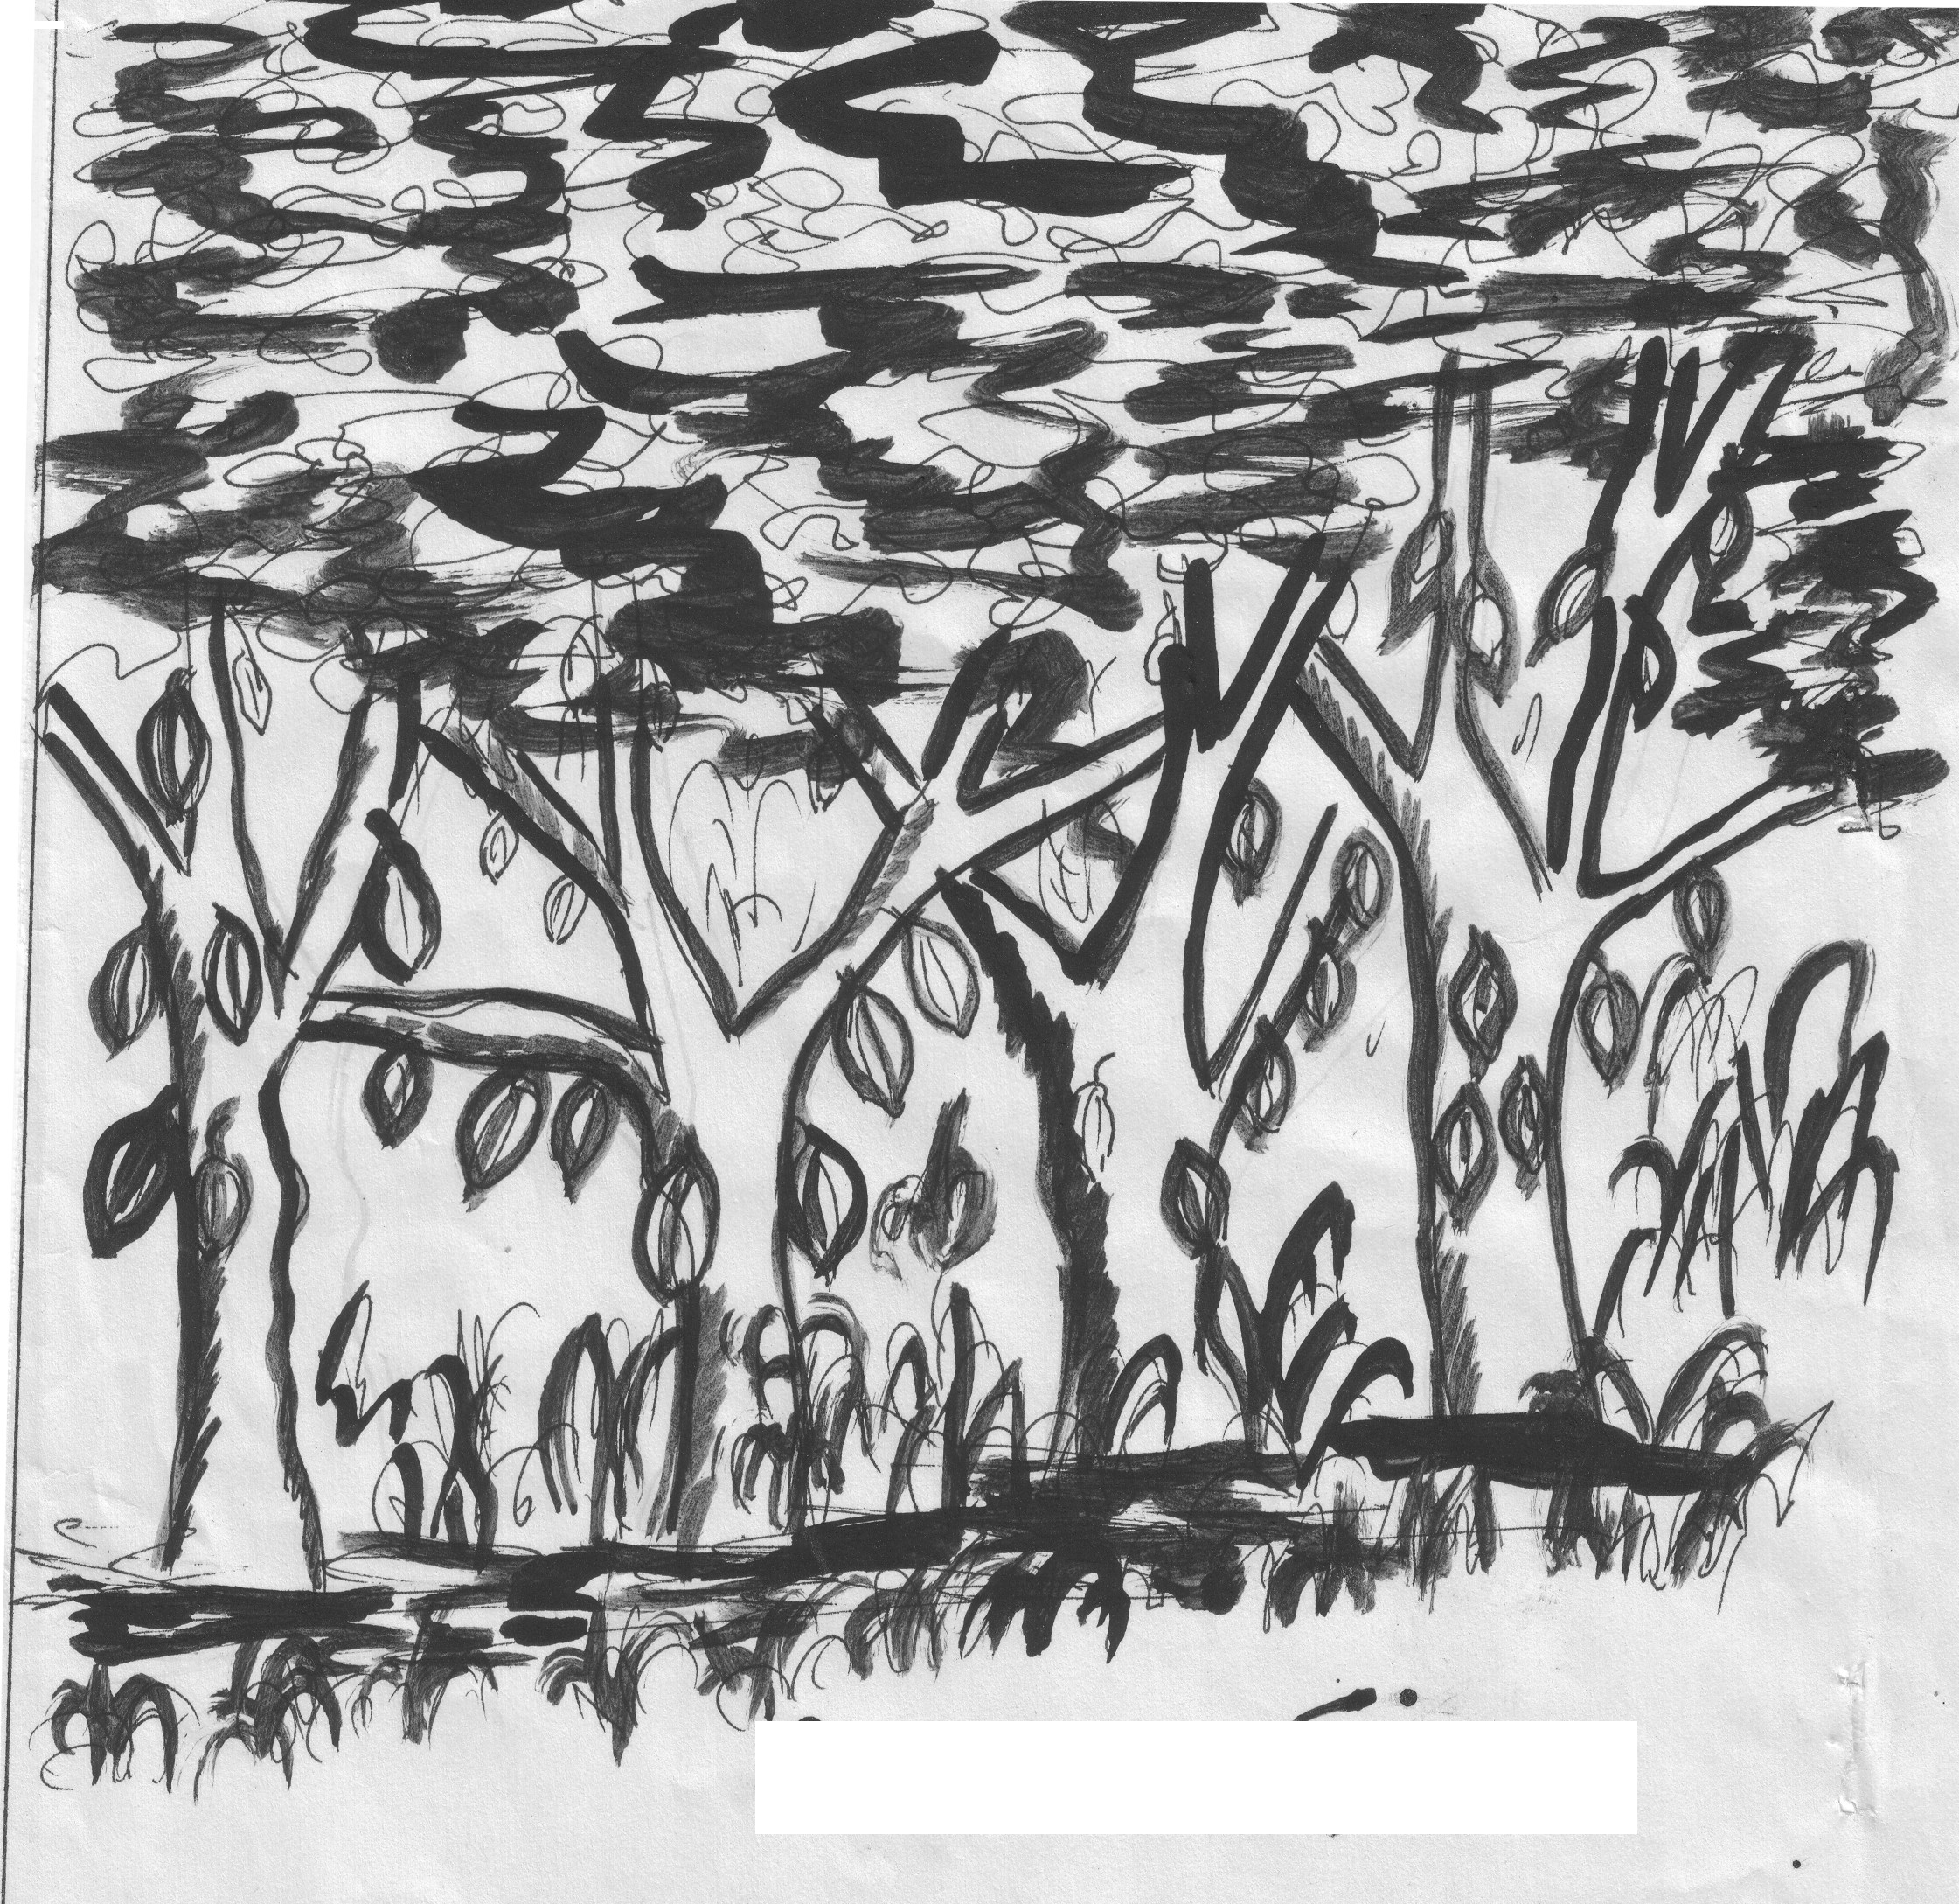
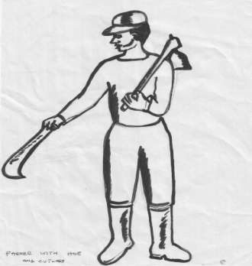

1.3. Other Businesses in the Business Flow Chart.
All other businesses in the community (transport, shops, carpentry, tailors, shoe making, bicycle repair, chop bar etc) can fit into the business flow chart.
Exs. 1, Other Local Businesses in the Flow Chart

Fill in the empty spaces using any local business that you are familiar with.
1.4. Compare Farm and other Businesses.
As far as the flow chart is concerned all businesses fit the same description. The differences can be seen only in the type of activity and the product/service made.
It can be concluded that the farm is like any other business (shops, transport, tailoring, food vendors, bakery, carpentry etc) which exist in the community and should be run as business. Some people apart from farming run some of these businesses but do not think of the farm as a business. They however, think of the shops, transport as businesses.

Module 1 Session 2
1.5. Foundation of a Successful Farm Business
Overall Objective
To help participants to identify the factors that constitutes the strong foundation of a successful farm business
Session Objective
By the end of the seesion participants should be able to:
- List or Mention the elements that form the foundation for a successful business
- List the three pillars of running a succeful farm business
Session Delivery Steps
- Ask the participants to mention some of the factors that they think will make farming a successful business
- Develop and summarize the list into three pillars of running a successful farming business (entrepreneur (farmer), the farm and the environment.
- Explain to participants that in order to run a successful farm business all the three element or pillars must be taken seriously and developed.
- Take each of the three elements in turn and discuss each in detail with the participants
Farmers as an Entrepreneur
Session Objective
At the end of the session:
- Participants should be able to unearth and utilize the personal potentials as farm business people
- Participants should also be able to identify the characteristics of a successful entrepreneur
Delivery Steps
- Based on the discussions, ask participants to explain who an entrepreneur is and what differentiate succesful ones from unsuccessful ones
- Ask participants to identify some succesful business people or farmers in their communities and suggest reasons for their success
- Ask participants in groups to list the characteristics of a successful business person and discuss the list with them.
- Show the diagram and discuss the importance of the pillars in the farm business
- Discuss with participants how they are going to deal with each pillar after the training and have them noted down for follow-up purposes
- In groups ask participants to identify their strong and weak charcteristics and discuss with them how they will improve on their weaknesses and build on their strengths
The Farm within the Environment
Session Objective
- Participants should be able to explain how the environment can contribute positively or otherwise to their farm business
- List the elements in the environment that can contribute positively or other wise to the success of the farm business
Delivery Step
- Discuss with participants what constitute the environment in general and specifically the business environmrnt
- In group ask the participants to list the environmental factors that could affective positively or negatively the farm business
- Let the small group elect a raporteur to present the group work to the participant. Each group should be given the chance to present their work
The Farm as an Enterprise
Session Objective: By the end of this session, farmers should be able to:
- Prepare adequately well before considering starting the farming entreprise
- Mention the factors to consider before going into farming as a business
- Plan their farm operations
Delivery Steps:
- Ask participants to be groups and share their experiences on what motivated them to go into the the production of the crops they are cultivating
- Ask participants to tell their colleagues the planning done before the start of the farm business- step by step
- Ask the discuss with participants the steps that they deem necessary but which they left out
- Through group work, let participants discuss the conditions necessary to start the farm enterprise

Notes to the Facilitator
1.5.1. The Farmer as an Enterpreneur
If the above processes are followed carefully, then the farm stands a better chance of becoming a successful farm business. These processes constitute the foundation on which to build a succesful farm business. The farm like a building needs a strong foundation on which it can stand against most difficulties. If the foundation on which the farm is built is not strong, it can hardly withstand the problems and threats that will confront it.
This foundation is built around three (3) inter-related pillars from which the farm may be able to grow and ensure success. The three pillars put together are referred to as the ‘Enterprise Triangle’. In summary the foundation looks at the farm owner (the entrepreneur), the kind of business (crop farm) that is being done and the management of the business where it is located (environment).

The Environment (location) Enterprise (Farm)

The Entrepreneur (Farmer)

Fig. 3. The Enterprise Triangle
The three pillars are: the Farmer (the person behind the business); the farm (the type of farm the person is operating) and the environment or location of the farm.
2.1. The Farmer as an Entrepreneur
The farmer as the owner of the business is the most important of all the elements because s/he takes decisions regarding the running of the business. His functions include: selection of the crop, study the market for the produce, organise resources (land, inputs, tools and equipment, cash) to cultivate the farm, harvest the produce and sell the produce for profit. The farmer requires knowledge and skills in: GAPs, management (planning, organising etc), information gathering, human relations and persuasion, be time conscious and prepared to learn new ideas to enable him perform his functions effectively.
This is the person behind the establishment of the farm. The person identifies a crop/s within the environment, conducts an investigation to prove that the crop will do well and that a market exists for it, he /she organises resources to start and run the business and reap the benefits/rewards of its success or bear the consequences of its failure.

2.2. The Enterprise
This is the crop that the entrepreneur will cultivate on the farm. The crop/s has been selected by the entrepreneur because of the belief, based on investigations carried out, that it will grow well in the area and that people (individuals and organisations) will buy the crop after harvest.
2.3. The Environment
The business that will be established will operate in a particular location/s (district/region/country). The question is whether the business exists in a conducive environment where it can grow and thrive.
The environment of a business is a combination of three main factors: the natural environment, the social environment and the economic environment. The natural environment in the farming is made of weather, soil, pest and disease pressure etc. The social environment includes the family of the farmer, government agencies, laws, farmers’ organisations, etc. The economic environment is characterised by the market, the economic situation of a country (e.g. the strength of a currency) or the services banks are offering.
The success of any business is therefore described in terms of the person running it, the product or service being offered and the location of the business. It is said that an entrepreneur runs an enterprise within a given environment.
3. THE FARMER AS AN ENTREPRENEUR
Of the three pillars the entrepreneur stands out as the most important and it is for this reason that s/he has been placed at the bottom of the triangle. The entrepreneur carries the enterprise and the environment on the shoulders and the success or otherwise of the business rest largely on his/her abilities.
Because he is the person behind the business (farm), it is important to deal with this pillar first. The farmer must be developed from three fronts in order that he will be an all round person. The areas are: i) Technical Knowledge and Skills ii) Entrepreneurial Competencies/Skills iii) Managerial Skills. The acquisition of knowledge and skills in the three areas are important so that the person will be able to overcome the problems emanating from the enterprise (farm) and the environment (location).
3.1. Entrepreneurial Competencies
Entrepreneurs possess certain qualities that enhance their abilities in solving problems that confront their businesses either from the enterprise or from the environment within which they operate. These include but not limited to the following.
3.1.1. Goal Setting. One of the most important facts of life is the ability to set goal for the things we do. This is to help us see and create pictures, images or describe the preferred future or target and the same goes for the farmer. By knowing the target the farmer sets direction as to where he wants to go. The goal must be realistic and achievable.
The farmer may have a goal like: “to cultivate a five acre mango or pineapple farm in three years”. This goal will depend upon the resources available to the farmer. His efforts from then on will be to cultivate this 5-acre farm. The goal will also help the farmer to convince/carry others (wife, labourers, and children) to come along with him.
3.1.2. Information Seeking. The farmer needs to constantly look for information on the business that he runs. An important role of the entrepreneur is to take decisions about the operations of the farm and his ability to take right decisions will depend upon the information available to him.
He collects information from his fellow farmers, technical people (experts), buyers/customers, suppliers of farm inputs, and the environment within which he operates. Information may also be available from newspapers, magazines, journals, national and community radio and television station programmes in the local dialect. In looking for and using information the farmer must be observant of his environment so that he can also make his own judgments of the issues at stake. He should be more open and respects the views of those that he deals with.
3.1.3. Systematic Planning and Monitoring. This is an often ignored phase in the process of establishing and running a business because most people are of the view that with money/resources everything will proceed smoothly.
In fact the opposite has proved to be true. The information available to the farmer will not guarantee success unless it is used to plan what the farmer wants to do. The plan should be related to the goal set. So the goal to have a five acre farm in three years should begin with a plan of what the farmer can do in the first six months or so, plan for the next year etc. The bigger goal is thus broken down into smaller achievable plans. The plan is however, monitored closely and revised in the light of feedback on how the implementation is moving.
3.1.4. Commitment and Persistence. An entrepreneur must be committed to his goal and plans and to show persistency in following a particular course of action to achieve them. He is not deterred by emerging difficulties and challenges in implementing his plans except where the problems are beyond his control. The entrepreneur takes repeated action or switch to alternative strategies to achieve the main goal.
A committed farmer will not change his goal every month unless the problem is beyond his control, as in the failure of the weather. Moreover, if the farmer sets goals that are unrealistically high he may not show commitment towards its implementation. If the goal is also too low the entrepreneur will not be too enthusiastic to implement it.
3.1.5. Risk Taking Ability. Risk is a fact of every human activity including farming business. Risk is present in every business because the plans that people make are based on the assumption that everything will work well. However, in reality some of the things, especially those that we don’t have control over, may go terribly wrong and derail these plans.
In order to overcome this problem the entrepreneur is advised to set realistic goals and plan well to reduce the risk of failure. Farming in particular is considered highly risky because a major determinant in its success, weather, is beyond the control of farmers. While this is true most farmers tend to have high self believe and ignore expert advice. Farmers are reluctant to take on new and innovative ideas and prefer the safe ground of copying what others are already doing or what they are familiar with.
The farmer can also reduce the risk factor in farming by exercising control over the other variables in business (type of seedlings, fertilizer, farm acreage, market demand, financing etc.)
3.1.6. Opportunity Seeking and Initiative. Most often farmers are not very much aware of the numerous opportunities that exist within their own environment for the development of their farms. Their daily routine involve going to their farms and back home, with occasional visit to the main market.
When the entrepreneur closely observes his environment he is able to identify new opportunities and seize them for the benefit of his business. In farming, these may be opportunities offered by support institutions and agencies. Farmers must therefore have their ears and eyes on the ground to be able to take advantage of these supports.
Farmers also miss a lot of opportunities because they are not prepared to take on new initiatives and prefer to do the things the same old way as before. The entrepreneurial farmer does not wait to be told or decide to inform almost everybody of what he intends to do. He always wants to be the first or with the first in most of the things he does. He doesn’t do it because others are doing it, rather he exploits new markets, take advantage of existing assistance programmes to advance the course of his farm.
3.1.7. Self Confidence and Independence. Self confidence is a feeling of trust in the abilities, qualities and judgement of the farmer to do things. It is so important in running any business that special effort should be made to develop it in farmers.
It comes about as a result of building high self-esteem. Most often people with low self-esteem lack self confidence. Such people also develop dependency attitude. They are also not comfortable in the presence of other people and therefore avoid others. Most business people including our farmers have this behavioural trait and it is the reason why they shy away from some support institutions.
It is an area that farmers must be helped to build and this can be done in lots of ways. As adults the farmers can be made to accept personal responsibilities of their actions i.e., avoid blaming others for their failures, they must be soft on self criticism which can destroy any self esteem that they might have.
Again doing things successfully brings happiness and motivate them to take on new challenges. If they are in groups each farmer may be given some responsibility that takes them outside their immediate environs. They may also need to develop their communication skills including: choice of words, eye contact, slow breath, cheerful facial look and knowledge of issues.
3.1.8. Interpersonal Skills and Social Networking. It is said that every business deals with people and as entrepreneurs, farmers will have to deal with all kinds of people (customers, workers, suppliers, competitors, banks, extension officers etc) in the course of running the business. Their success in business will therefore depend to a large extent on their ability to establish healthy relations with all the people they will deal with.
The skills of building healthy relations with others are closely linked to our self confidence level. Generally, people who are shy, timid, boastful and aggressive are unable to have cordial relationship with others.
Some of the simple costless ways of improving our human relations include: keeping a cheerful, smiling face; acknowledging others through greetings and respecting their views in conversations; accepting compliments from people; accepting our mistakes and faults etc.
The process of building healthy relations is through:
• rapport building that is, using the best communication skills to create a good first impression;
• building trust with those we interact with and
• trust maintenance.
By following these simple processes we will be able to connect to more people than we ever imagined.
Entrepreneurs also use the smooth relations with others to create social network of acquaintances especially those who can assist them to develop their businesses. Farmers belong to various economic and social groupings and they must use their membership to advance the course of their businesses.
3.1.9. Positive Attitude. Attitudes can be expressed positively or negatively. Positive attitudes creates our strengths, hopes, aspirations, opportunities etc whilst negative attitudes creates our weaknesses, fears, worries, frustrations, problems etc. Therefore in our daily lives, the difference between a positive attitude and a negative one can often spell success or failure respectively. Most often business owners develop the negative attitude of ‘it won’t work’ and this hampers their ability to solve problems that they face.
Entrepreneurs have positive attitudes towards issues because they trust in their abilities and judgment to solve those problems confronting them. They spend their time and energies by looking at the positive sides of issues and do not allow personal likes and dislikes to influence their approach in problem-solving.
They think and practice positive thinking on issues when they deal with their customers, workers, competitors, bankers, extension officers etc such that these people are persuaded to react favourably/positively towards them. They are then able to get some of the best deals for their businesses.
3.1.10. Stress Taker. As the central figure in the business, the farmer will have to cope/deal with many difficult situations at the same time and also be able to make right decisions mostly involving emotional and physical stress. This can be very traumatic and can cause the farmer health problems which adds cost to the business.
The first approach is to avoid making promises (to who-ever) that you cannot keep. He must always remain calm in the face of any problem. This means he must tackle the problems head-on and avoid expressing high emotions. Rest and or moving away from problems for a while may also be necessary in reducing stress in times of difficulties. These personal traits that are required to run a successful business are by no means exhaustive. It is also not possible to have these traits in the same
12
amount and it is important for business people to identify their weak areas and work hard to make them better and to further strengthen those areas that they are good at.
4. THE FARM WITHIN THE ENVIRONMENT
The environment refers to all the conditions (internal and external) within which the farm is conceived, developed and managed successfully. These conditions must be examined to help the entrepreneur take advantage of opportunities and prepare for threats that exist within the environment. Knowledge of the environment is crucial.

4.1. The Internal Environment
These are issues that are internal to the business and which the farmer has greater control in dealing with them. They include:
• Our Family and the Business. The farmer may need or receive the support of family members in running the farm but this should be done on sound business practices. Keep non-business family issues separate from the business. Family members who work on the farm must treated just like any other farm worker.
• The People who work with us. People will work hard if we provide them with the basic needs of life: i) care that makes them feel a sense of belonging and love; ii) show them respect to make them feel that they also matter and have power; iii) allow them to think for themselves and take initiative; iv) share jokes and laughter which provides them with fun and v) provide physical and emotional security which help them to feel secured.
• Managing the Business. Farmers must have the courage and the ability to better manage their businesses for success. They should defer gratification, sacrifice especially in financial matters to help their businesses grow. They must pay themselves salaries at the end of the month and avoid waste of resources. They must strictly separate their private matters from that of the business if they want to succeed.
4.2. The External Environment
These are factors that lie outside the influence and control of the farmer and his business but which greatly influence the fortunes of the business, depending on how the farmer identifies and uses them. They are found in the following major areas:
• The Weather. This is the greatest external factor that greatly affects the farming business, positive in some ways and the opposite at certain times. To reduce the negative effects farmers can look at modern farming methods.
• National and District Authorities. There are several laws, rules, regulations that govern the activities of all businesses and the farmer is expected to know and obey them. Major government policies (its vision, current thrust of policy direction etc) provide key information for all businesses.
Others like the banking interest rates do not favour the farmer and he will need to be abreast with them so he can take advantage of emerging support and prepare against threats. At the local level most district assemblies have their development plans from which several opportunities may be generated. Donor agencies also offer support to particular farming activity
• There are also traditions, customs and beliefs of the society within which the business is operating. These are certainly beyond the control and influence of the farmer and it is expected that these traditions etc will be followed so that the business will exist peacefully in the community.
Dealing with such outside agencies and institutions requires deeper knowledge of what they do and also the human relationship skills of the farmer.
• Road Access is especially important when it comes to harvesting and marketing to keep costs of transportation low.

5. THE FARM AS AN ENTERPRISE
An important aspect of the entrepreneurial activity is the establishment of a viable and sustainable enterprise or business. The first task of any one wishing to go into business is to think of the type of business to establish. In the case of the farmer it will be what crop/s to grow. But among the crops the farmer has to choose among a certain number of varieties; this choice should consider the market as well as natural conditions already.
The objective of the farm enterprise is to produce good quality produce which will be sold to generate profit to meet the needs of the farmer and also to re-invest some into the farm.
To be able to survive and grow, the farm has to produce crops that customers will find attractive. The price must meet the pockets of the buyers and must also be reasonable to cover cost of making the farm and generate enough profit for the owner and to sustain the enterprise. This means that the business must be well planned.
Planning the farm means preparing and organising the business so that resources are not wasted and money is saved whenever possible. The better the business is planned, the better its chances of success. Planning must be done when someone wants to start a new farm or a farmer wants to expand his existing farm. In both cases resources will be needed to undertake the activity and a number of things must be done as part of this planning.
5.1. The size of the Farm.
The farmer must decide how many acres he intends to cultivate for a new farm or how many acres he wants to add to the existing farm if it is an expansion. This will depend upon a number of factors which the farmer must carefully consider. These will include the following:
5.1.1 Market considerations. This is very crucial so that any investment made can be regained. The farmer will need to carry out a market survey to find out whether the crop to be produced will be bought. This survey may be a combination of:
• Talking to farmers who are already in the business, processing units around the location of the farm, buying agencies and individual traders etc.
• Visiting local and surrounding markets to find out the supply and demand for oranges.
• Current quantity, quality and grading system being used and prices on offer.
• What trade or transaction practices exist between producers and buyers?
• Exploring new markets based on new uses of oranges.
• Current technology in use on farms and whether the farmer can afford it.
This means the farmer must be observant of his environment to assess the market (current and potential) for the product. In fact identifying one’s target market is so crucial that time spent on it will be worthwhile.
5.1.2. Resources available to the Farmer. Another crucial consideration in determining the size of the farm apart from the market consideration is the resources that the farmer has. In fact this factor is so linked to the market such that the farmer will have to be extra careful. A farmer may go and borrow money from the bank as a result of a firm order from a buyer but may be let down by the buyer or the weather, which may result in bank debts. As much as possible the farmer must not be carried away by profits alone in investing in farming activity.
Generally it is advisable for the farmer to start with a smaller farm size to ensure good maintenance. Well maintained citrus/mango/chilli pepper/ pineapple will be much more productive than poorly maintained farm. On the other side costs for weeding and harvesting are charged by the size of the farm. The farmer should make the best use of his resources which therefore means to go for small high productive units instead of large low productive units.
5.2. The Needs and Costs of the Business
The next stage of the planning is to assess the needs of the farm. The needs of the farm consist of all the items needed to get the business off the ground. It is thus important to decide on the size of the farm in order to list the items needed for it. The farmer must come out with the inputs and quantities that will be needed. If the farm is a new one the inputs are called Start-Up Needs. Where the farm is to be expanded these needs are called Additional Investments. Start up/additional needs include but not limited to:
• Finding suitable land for the farm. The farmer may require expert advise if he is in doubt of the suitability of the land
• Identifying sources and availability of other inputs namely: equipment and tools, seedlings, chemicals etc.
• Labour needs. Farming is labour intensive especially where the farmer cannot afford modern equipment and therefore labour requirements must be carefully considered from land clearing through planting, farm maintenance to harvesting,
• The farmer has to consider some other needs of the business. It may include services of transport, spraying, ploughing, banking, use of and payments for experts etc.
The farmer must then attach costs to these needs that have been identified because all or some of them will be purchased on the market. Table 4 below can be used as a guide in putting these thoughts together.
It is however important to differentiate between the costs that are fixed, those items which are bought only once and stay in the business for a long time (like tools and equipment) from those items that the farmer will spend money on regularly (like, seedlings, fertilizer, labour, other services) which are called working capital. The total of these costs will give the farmer an estimated total cost of starting the farm or the expansion. He then compares this cost with all the resources available to him and if the estimates are too high he may have to revise them so he doesn’t begin and get stuck in the middle of the project.
Having known the cost of the project it will then be the time for the farmer to look for sources of financing the project. The farmer can rely on his own savings or look for alternative sources of funding (family members, friends, suppliers’ credit, bank loans etc). The farmer must consider the cost of borrowing money from whatever source before going in. The farmer may not need to invest too much in the fixed items and find itself without money to pay for the other items that are crucial to get the farm operational. He may even rely on hiring the services of some fixed items whenever possible.
5.3. Sales Projection
It is also important for the farmer to make estimates for the quantities to be harvested and the sales revenue to be generated over a period of time based on the market survey that has been done earlier. For citrus/ mango projection should be based on starting harvesting after 4 years onwards. It is better for the farmer to be conservative in the quantities to be harvested and sold and the revenue to be generated. Since the crop will be harvested over a period of time the quantities can be increased from year to year.
5.4. Will the Farm be a Profitable Venture?
The rough cost and revenue estimates will give the farmer an idea as to the profitability of the farm. Changes may be necessary in the cost and sales estimates as the farmer may deem it fit during the planning process. It is good however, to be liberal on cost estimates and conservative on revenue estimates. To determine the profitability or otherwise of the farm business, there will be the need to carry out a simple gross margin analysis. The way to calculate gross margin will be looked at in a later session.

Module 2 Session 1: Planning for the Season
Session Objective: At the end of the season, participants should eb able to draw a viable plan to guide in the farm operation for the season.
Delivery Steps:
- In group, ask the participants to define planning and why its important to plan before the start of the farm business and during the start of every farming season. Let the groups make presentation on their answers
- Ask the participants to state the steps involved in planning.
- With the use of the planning book explain the porcesses involved in planning for the season. Give examples
- With the use of the planning and record keep book, let participants carry out practice planning based on the demands of the season. Go through planning for the season using the materia; availabe with them.
2.1. Principles of Planning
2.1.1. What is Planning?
Planning is preparing a sequence of action steps that will assist you to achieve a specific goal. It is a map that shows you where you want to go and how to get there.
2.1.2. Reasons for Planning
Planning helps the farmer to determine the resources needed in order to achieve his/her objective.
It helps the farmer to identify future problems that his/ she will encounter during plan implementation.
It helps the farmer to make the best use of his/ her resources. Unstructured actions cost more because he/ she moves forth and back.
It helps the farmer to measure his/ her own successes/achievements in handling a task that he/ she set out to do within a particular period of time.
2.1.3. Steps in Planning
- Set a goal, that is, determine where you want to go. The goal must be SMART,
- List the objectives to be achieved.
- List the activities to be undertaken under each objective.
- For each activity specify the person responsible and the time frame needed.
- Next indicate the resources needed to undertake each activity in broad terms. Eg an activity may require the hiring of labour, purchase of seedlings etc.
- State specific periods during which the plan implementation may be reviewed.
2.2. Planning a New Farm or an Existing Farm
2.2.1. Set Farm Business Goal
The farm business goal can be short medium or long term. A long/medium term goal can be broken down into a series of short term goals. Egs: i) To start a new 2-acre chillie pepper or mango farm by the end of 2011season. or ii) To expand my farm with an additional 3-acres by the end of 201 season. The goal must be SMART.
S stands for Specific. In the above example, the 2-acre maize farm is specific
M stands for Measurable. 2 acres in the goal is something that can be measured.
A stands for Achievable. This refers to the time for the goal to be achieved.
R stands for Realistic. The goal should be set with the resources available to the farmer in mind.
T stands for Time-bound. The goal is set within a reasonable period of time.
Objectives of the Goal
These are milestones to be achieved throughout the goal implementation. The number of objectives to be met will depend upon the goal set. Using the cultivation of new 2-acre mango farm we may have the following objectives:
- To acquire 2 acres land within two months.
- To buy 300 mango seedlings seedlings by the end of the first two months.
- Prepare the 2-acre land and do planting by the end of the fourth month.
- To carry pegging and lning, transplanting, out regular farm maintenance, weeding etc.
2.2.3. List Time-bound Activities with Responsibilities and Resources Needed.
For each objective which you set list the activities you must undertake and within which time to enable you achieve the objective. Also indicate the person who will undertake the activity.
Activities: (Step by step) Refer to Planning and Record Book for details on how the planning for the season will be done. Planning looks at the farm activities, cost of inputs and labour (hired and family labour) Attached is the best case sample to help the farmer plan his/ her actitivities with cost attached to each of the inputs and labour (hired or family labour).
2.3. Farm Budgeting
2.3.1. What is a Budget?
A budget is a forecast of an entity’s costs and income for a particular period of time normally based on a cycle. The entity may be an individual, a business, a group or a government. A cycle is the time from putting in the effort until reward is earned.
For a business the cycle is from the time of buying inputs to the time of selling the product or produce for cash. The business cycle will therefore differ from business to business. For the farmer the cycle is described in terms of season. A budget may be prepared for one season or more depending upon the goal.
2.3.2. Preparing the Budget (Cost of Inputs and Labour)).
The farmer will use the planning done to prepare the budget (cost) estimates. The farmer needs to express the column on cost of inputs and hired/ family labour in terms of money. Refer to the planning and record book for example of how this is done.
2.3.3. Planned total costs of activities.
This is the planned total costs of all activities under the plan. It is the amount needed to implement the plan. Be liberal when estimating costs because of inflation.
2.3.4. Planned gross revenue from sales.
For a business an estimate of what will be sold under the plan is important. In our plan since we have an estimate of the quantity of harvest we can safely estimate how much we will make from sales. Be conservative when making estimate on revenue.
2.3.5. Planned Variable Cost
This is expressed in terms of the total planned cost of inputs, plus total planned cost of hired labour plus total planned cost of family labour
2.3.6 Planned Gross Margin
This is the planned total gross revenue minus the total planned variable cost
2.3.6. Profit/Loss of the Plan.
The difference between the total gross revenue and the total planned variable cost will show the viability or otherwise of the plan. If the farmer will incur a loss, he/ she should carefully look at the gross margin again before investing any money.

Session 2 Calculation of Gross Margin
Refer to Frank’s presentation and also to the Planning and Record Book for details.

Module 3 Session 1 Farm Record Keeping
Session Objective: By the end of this session farmer should be able to fill in farm record books and subsequently keep records of their farm business activities.
Refer to Frank’s presentation and Planning and Record Book for details.

