Plot Data
Farmer
Farmer code
Plot code
Crop
Crop variety
Plot size
Plant population
Planting date

For soft copies contact AFC Consultants International: c.arndt@mail.ru

Agronomic Activities
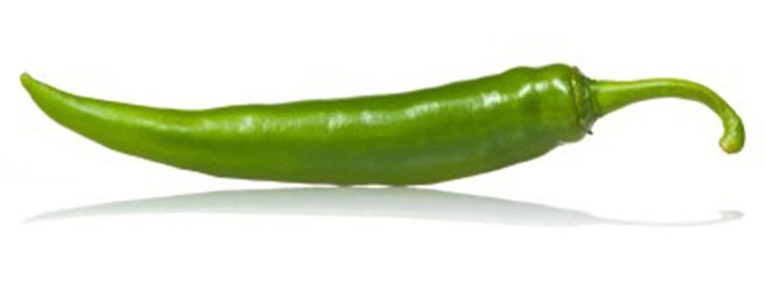
Field Records Page 1
Farmer Code:
Plot Code: Stage of growth:
Crop: Var:
Date Planted: Plant Population:
Date: | Agronomic Activity | Operator name

Field Records Page 2
Date: | Agronomic Activity | Operator name

Field Records Page 3
Date: | Agronomic Activity | Operator name

Field Records Page 4
Date: | Agronomic Activity | Operator name

Field Records Page 5
Date: | Agronomic Activity | Operator name

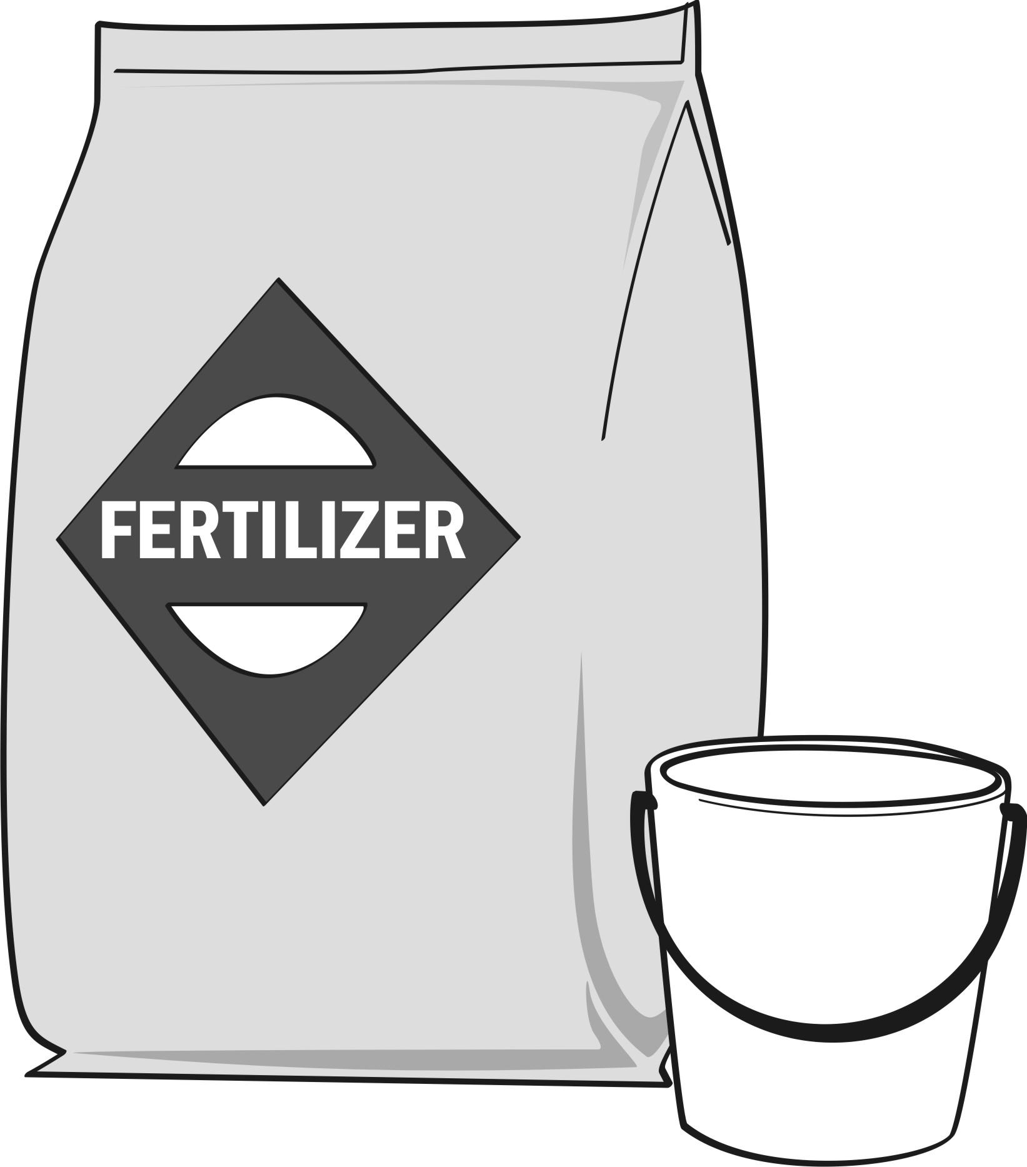
Fertiliser Application Records
Farmer Code:
Plot Code: Stage of growth:
Crop: Var:
Date Planted: Plant Population:

Page 1
Date | Fertiliser type | Total amount and amount/plant(kg or ltr) | Application method  (circle one) | Application machinery | Operator name
foliar
broadcast
strips
foliar
broadcast
strips
foliar
broadcast
strips
foliar
broadcast
strips
foliar
broadcast
strips
foliar
broadcast
strips
foliar
broadcast
strips
Fertiliser Application Records
Farmer Code:
Plot Code: Stage of growth:
Crop: Var:
Date Planted: Plant Population:

Page 2
Date | Fertiliser type | Total amount and amount/plant(kg or ltr) | Application method  (circle one) | Application machinery | Operator name
foliar
broadcast
strips
foliar
broadcast
strips
foliar
broadcast
strips
foliar
broadcast
strips
foliar
broadcast
strips
foliar
broadcast
strips

Pest Scouting
- Mark 5 rows at random leaving out the rows at the edges. Different sampling sites should be chosen each time the crop is inspected.
- Walk along the rows and select a point and inspect 5 plants from soil to the leaves at this point.
A sudden, permanent wilt of the entire plant without yellowing.
Bacterial wilt
- Check and count the pests and diseases listed below and indicate the scale below.
- Check for the presence and abundance of natural enemies
- Decide whether to take actions, and what actions to take. You can use the table as a guideline.
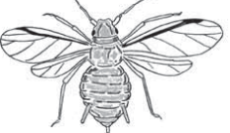
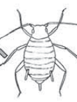
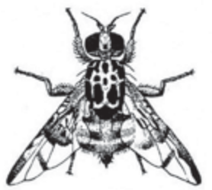
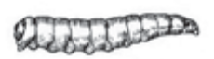
Aphids
For early detection check for winged aphids, which start new colonies on young shoots.
Check for small colonies on young leaves and shoots. When the numbers are high the plant maybe covered with honeydew and black sooty mould.
Check also for the presence of natural enemies. Parasitised aphids, known as mummies, are easily recognised, as they turn hard, and brown in colour.
Larvae and adults of ladybird beetles, lacewings and hoverflies are normally found within or near the colony of aphids.
Monitor fruits for egg-laying scars (dimples or small white specks in the middle of a shallow indented area on the surface of the fruit). Check appearance of flies on traps. Fruit flies are 4-7 mm long.
Fruit flies
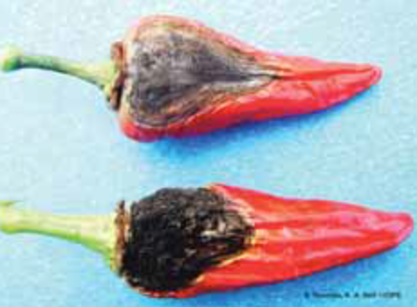
Anthracnose
Spots show the characteristic concentric ring (target-shaped) appearance.

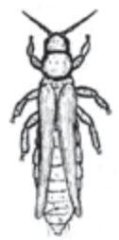
For early detection check the underside of leaves, the apices of young fruits and shake flowers on a white piece of paper and look for the thrips. Monitor adult thrips by hanging coloured (blue, yellow or white) sticky or water traps in the nursery or field.
Thrips

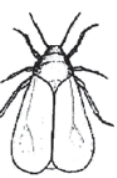
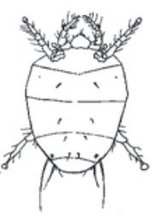
Light chlorotic to bright yellow patches develop on upper side of older leaves. On the lower leaf
surfaces a fine talcum-like powder is seen.
Powdery mildew
Whitefly
For early detection check the underside of young leaves for presence of adults and eggs. Whitefly adults resemble very small moths (about 1 mm long).
Mites
For early detection
check for symptoms such as necrosis on the lower leaf surfaces, deformation (elongation and curling) of young leaves.
Pest Monitoring Form: Field Scouting Sheet
Plot Code: …………….Crop: ………….………Variety: …….…...………..Planting Date: .….…....……….Stage of crop: ……..…….………

 | Date:………………… | Date:………………… | Date:………………… | Date:………………… | Date:…………………
 | Average No. per plant;  Level (high; med., low) | Average No. per plant;  Level (high; med., low) | Average No. per plant;  Level (high; med., low) | Average No. per plant;  Level (high; med., low) | Average No. per plant;  Level (high; med., low)
Aphids (AD)
Fruit flies (FF)
Thrips (TH)
Whiteflies (WF)
Mites (MT)
Fruit worms (FW)
Mealy bugs (MB)
Leaf miner (LM)
Termites (TT)
Other
Other
Disease Monitoring Form: Field Scouting Sheet
Plot Code: …………….Crop: ………….………Variety: …….…...………..Planting Date: .….…....……….Stage of crop: ……..…….………

 | Date:………………… | Date:………………… | Date:………………… | Date:………………… | Date:…………………
DISEASES | % of plants affected; Level (high; med., low) | % of plants affected; Level (high; med., low) | % of plants affected; Level (high; med., low) | % of plants affected; Level (high; med., low) | % of plants affected; Level (high; med., low)
Anthracnose (AT)
Bacteria wilt (BW)
Powdery mildew (PM)
Damping Off (DO)
Fusarium wilt (FW)
Cercospora leaf spot (CL)
Bacteria soft rot (BS)
Viruses (V)
Blossom-end rot (BR)
Sunscald (SC)
Other:
Other:

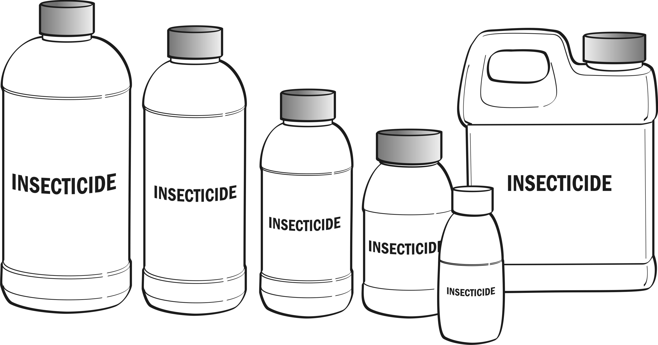
Plant Protection Records
Farmer Code:
Plot Code: Stage of growth:
Crop: Var:
Date Planted: Plant Population:

Page 1
Date | Product name / Active ingredient | Target pest / disease | Area size  (acres) | Amount of product used  (ltrs) | Dosage per 15 ltr of water  (ml) | Preharvest period (days) | First harvestable Date | Re- entry period  (days) | Operator name | Application equipment | Authorization  (Signature of farmer)

Plant Protection Records
Farmer Code:
Plot Code: Stage of growth:
Crop: Var:
Date Planted: Plant Population:

Page 2
Date | Product name / Active ingredient | Target pest / disease | Area size  (acres) | Amount of product used  (ltrs) | Dosage per 15 ltr of water  (ml) | Preharvest period (days) | First harvestable Date | Re- entry period  (days) | Operator name | Application equipment | Authorization  (Signature of farmer)

Plant Protection Records
Farmer Code:
Plot Code: Stage of growth:
Crop: Var:
Date Planted: Plant Population:

Page 3
Date | Product name / Active ingredient | Target pest / disease | Area size  (acres) | Amount of product used  (ltrs) | Dosage per 15 ltr of water  (ml) | Preharvest period (days) | First harvestable Date | Re- entry period  (days) | Operator name | Application equipment | Authorization  (Signature of farmer)

Calibration of Machinery (Example)
Date | Calibration conducted | Your application rate
 | 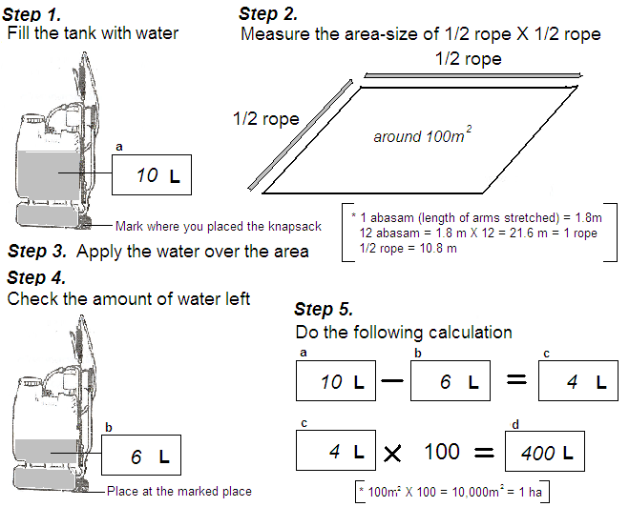 | d  400 L / ha  → This is the amount you apply per ha at your normal speed.  Now check the label of the pesticide for the application rate per ha.  If it is 200 g/ha, then it is 200 g per 400 L  Per knapsack (10 ltrs), you will then need:  200 divided by 400 x 10  = 5 g
Name
Nozzle Type/ pressure
Blue
/ High pressure

Calibration of Machinery
Date |  | Calibration conducted |  |  | Your application rate
d
L / ha
→ This is the amount you apply per ha at your normal speed.

Now check the label of the pesticide for the application rate per ha.

If it is ___ _/ha, then it is ___ _ per L

Per knapsack of ltrs you will then need:

___÷ L x
= ___ _ per knapsack
Name
Nozzle Type/ pressure
 | Date  Maintenance of Machinery |  | 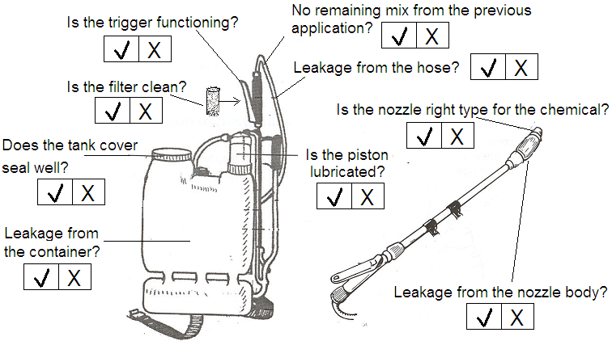 | Any repair, replacement of parts to be done |  | Done
 | 4th March 2015 |  |  |  |  | Done
 |  |  |  | Filter needs to be cleaned |  | V
 | Name |  |  |  |  | V
 |  |  |  | Piston needs to be lubricated |  | V
 | Eric Quaye |  |  |  |  | V
Knapsack No.
(If there is more than one)
 | Knapsack No.2
 | Date |  |  | Any repair, replacement of parts to be done |  | Done
 | Name
Knapsack No.
(If there is more than one)

Stock Inventory
Name: _____________________________ Name: _____________________________
Unit: _____________________________ Unit: _____________________________

Date | Incoming Stock | Outgoing  stock | Refe-  rence  plot | Balance
Date | Incoming Stock | Outgoing  stock | Refe-  rence  plot | Balance
Harvesting Records Page 1
Farmer Code: GGN:
Plot Code: Stage of growth:
Crop: Var:
Date Planted: Plant Population:

Date | Quantity Harvested | Total Weight (kg) | Exportable (kg) | Remarks

Harvesting Records Page 2
Farmer Code: GGN:
Plot Code: Stage of growth:
Crop: Var:
Date Planted: Plant Population:

Date | Quantity Harvested | Total Weight (kg) | Exportable (kg) | Remarks

Total | From:  To:

